2. For a seven-term moving average filter, write an expression for the
a. difference equation
b. impulse response
c. transfer function
d. frequency response

3a. Sketch a frequency response for a seven-term moving average filter using dB for magnitudes and degrees for phases. Use digital frequency steps of π/8 radians or smaller.

3b. With reference to the frequency response sketch, explain why this filter can guarantee that no pass and phase distortion will occur.

8a. The magnitude response for a filter in a 22kHz sampled system in Figure 9.70. Determine the:
a. Pass band ripple
b. Stop band ripple
c. Bandwidth (Hz)
d. Stop band attenuation
e. Center frequency (Hz)
f. Transition width (Hz)
FIGURE 9.7:
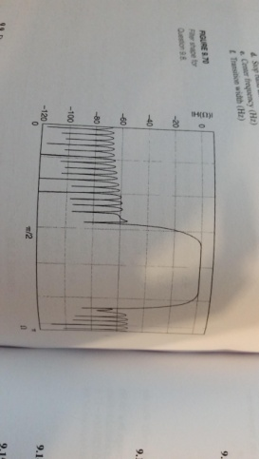
10. Draw a nine-term windows, w[n] versus n, for each of the following window types:
b. Hanning

11. Draw magnitude responses, |W(Ω)| versus Ω, for nine-term windows of each of the following window types:
b. Hanning

12. For each of the following low pass filter specifications, select an FIR window type and identify the number of terms needed to meet the requirements:
b. Stop band attenuation 50 dB; transition width 2kHz; sampling frequency 5kHz
d. Pass band gain 10dB; stop band gain - 30 db; pass band edge frequency 5kHz; stop band edge frequency 6.5 kHz; sample frequency 22kHz

14. Find the number of zeros, poles, and coefficients that characterize an FIR filter with:
a. N = 51 terms
b. N = 101 terms

